Columbia Pain Management, P.C.

1010 Tenth St Hood River, OR 97031

3601 Klindt Dr Ste 200 The Dalles, OR 97058
P: 541-386-9500 F: 541-386-9540

6542 SE Lake Rd Ste 101 Milwaukie, OR 97222
P: 503-654-5636 F: 503-654-5638

Dear Patient,

Thank you for scheduling your consult with Columbia Pain Management!

Enclosed you will find a financial agreement/medical release form, medical history forms, and a copy of our privacy policy. These forms must be completed and brought with you to your appointment. If these forms are not completed, your appointment will be rescheduled. You will also need to bring any medical insurance cards or claim number information.

Our office hours are Monday-Friday 8 am to 5 pm. When our office is closed, you may call the office phone number and leave a message.

We have a 24 hr cancellation policy. If you cancel this first appointment with less than 24hours notice, you will not be rescheduled. If you are being seen on a continuing basis and cancel an appointment with less than 24 hours notice, you will be charged $50.00.

We do require co-payments, deductibles and non-covered charges to be paid at the time of service. Your appointment will be rescheduled if required payments are not brought with you.

Columbia Pain Management has a policy of collecting a UDS (urine sample) on all new patients to assist the provider with your overall pain management plan. This is now considered standard of care in cases where patients are, or may be, provided pain medication for non-malignant pain. Refusal to provide a urine sample will limit our therapeutic options for your pain management treatment.

If you have any questions, please call our office. We look forward to meeting you.

Sincerely,

The Staff of Columbia Pain Management, P.C.

PATIENT NAME:____________________________ DATE:________________
For Office Use Only:

D.O.B.____________ Age:___________ Gender: [ ] male [ ] female

Referring Physician:___________________________

Reason for Referral:_________________________________________________________________________

Numerical Pain Rating Now:__________

Please Draw Your Pain

xxxxx Burning 00000 Aching ##### Pins and Needles = = = = = Numbness

Please use Black Ink

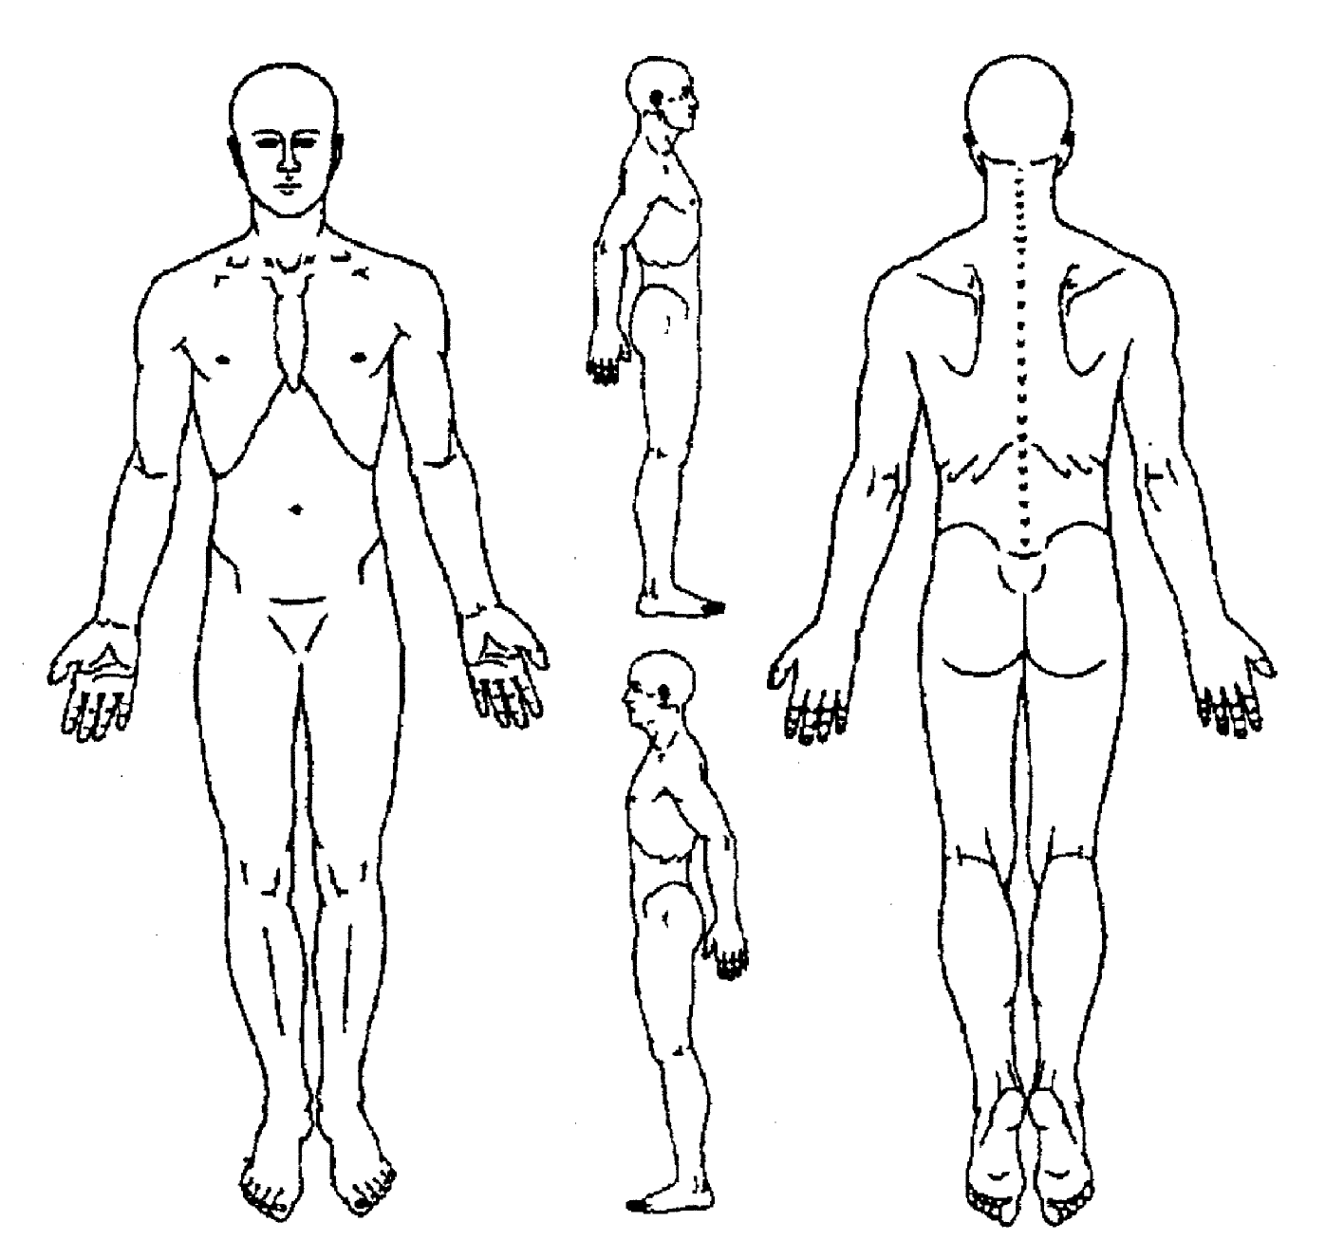

PAIN QUESTIONNAIRE

History of Present of Illness:
Please choose the statement that best describes your pain:

[ ] my pain is mostly in my back

[ ] my pain is mostly in my leg or legs

[ ] my pain is mostly in my neck

[ ] my pain is mostly in my neck or arms

[ ] my pain is everywhere

[ ] my pain is ______________________

When did your pain start?

If this is a motor vehicle crash or work related injury, what is the date of injury?

How did your pain start?

What makes your pain worse?

What makes your pain better?

Do you notice other symptoms that accompany your pain?

Do you feel depressed?

Have you lost control of your bowel movements or your bladder?

Are your arms or hands weak since your pain started? [ ] Yes [ ] No

Are your legs weak since your pain started? [ ] Yes [ ] No

Previous Work-up:
Please check below the tests that have been done to explore the cause of your pain. Please indicate which doctor ordered the test and when & where it was performed.

[ ] CT or MRI scans [ ] X-rays

[ ] Blood tests (arthritis, diabetes, liver) [ ] Bone Scan

[ ] Nerve conduction tests [ ] Bone density test

[ ] Discography (pressurizing discs)

Previous Treatments:

What other treatments have been tried for your pain? Please check those that apply

[ ] Physical therapy [ ] Epidural injections

[ ] Spinal manipulation/massage [ ] Acupuncture

[ ] Nerve Blocks [ ] Spinal Cord Stimulator

[ ] Implanted pain pump [ ] Vertebroplasty/kyphoplasty

[ ] Botox/phenol injections [ ] Trigger point injections

Surgeries for Index Pain:

Did you have surgery for your pain? [ ] Yes [ ] No

Please list your surgeries, dates, and surgeon here:

_______________________________________________________________

_______________________________________________________________

_______________________________________________________________

Past Medical History:

What other medical problems do you have?

1. 4.

2. 5.

3. 6.

Additional Surgeries:

What other surgeries have you had? (Please indicate year performed)

_______________________________________________________________

_______________________________________________________________

_______________________________________________________________

Medications:

Please List your current medications

1. 6.

2. 7.

3. 8.

4. 9.

5. 10.

Other Medications Trialed for Pain:

What other medications have been tried for your pain?

1. 5.

2. 6.

3. 7.

4. 8.

For Office Use Only:

Allergies: Have you ever had an allergic reaction to a medication? [ ] Yes [ ] No

If so, what medication and what reaction?

Social History:
Please indicate how often, if ever, you engage in any of the following activities:

[ ] Smoke cigarettes, pipe, or nicotine chew (number per day: _________)

[ ] Drink coffee, Tea, Cola or soda with Caffeine (total number of cups per day: ________)

[ ] Drink Alcohol Beers per day________
Wine (glasses) per day_______
Mixed Drinks or hard liquor per day ______

Do any first degree relatives (mother, father, brother, sister, children) have a history of addiction to alcohol, medication or drugs? [ ] Yes [ ] No

Do you have a personal history of addiction to alcohol, medications, or drugs?
[ ] Yes [ ] No

If yes, have you had treatment for addiction or chemical dependency

[ ] Yes [ ] No

Exercise:
How often do you exercise in an activity that is at least moderately intense for you:

[ ] Daily [ ] Every other day [ ] 2 times/week
[ ] Weekly [ ] Monthly

Type of exercise: _____________________________________

Activities of Daily Living: (see pain outcome profile as well)

Have you fallen because of poor balance, passing out, or weakness?
[ ] Yes [ ] No

Do you use a mobility device such as a walker, cane, motorized scooter or wheelchair?
[ ] Yes [ ] No

Type of mobility of device: _____________________________________

Do you have any difficulty caring for yourself that has not been covered in another part of the intake paperwork? if so, please explain.

_______________________________________________________________

_______________________________________________________________

_______________________________________________________________

Vocational:

Are you currently employed and working? [ ] Yes [ ] No

If yes,

Name of company:_________________________________

Job title:_________________________________________

How long:_______________________________________

Is this a work-related pain issue or injury? [ ] Yes [ ] No

If yes, what is your accepted condition?

If yes, are you interested in returning to your previous job?

If yes, do you currently have restrictions or did your doctor put you on light duty?

Are you receiving medical disability benefits or worker’s compensation time loss?
[ ] Yes [ ] No

Do you think that you can do your job with the level of pain you usually have now?
[ ] Yes [ ] No

Family/Community:

Are you married? [ ] Yes [ ] No

Do you have children? [ ] Yes [ ] No

Do you have active hobbies? [ ] Yes [ ] No

What do you do for enjoyment?

What clubs or organizations do you belong to?

Spiritual activities (church, meditation, etc.):

Family Medical History:

Is there a history in your blood relatives of the following problems? If so, who?

[ ] Depression

[ ] Suicide

[ ] Fibromyalgia

[ ] Irritable bowel syndrome (IBS)

[ ] Disabling Headaches

[ ] Chronic pain

[ ] Disabling arthritis

[ ] Severe mental illness

[ ] Alcoholism or drug addiction

Review of systems:

Are you having any of these symptoms? Please check those that apply

[ ] Recent fevers (last 3 months)
[ ] tiredness
[ ] swollen feet or hands
[ ] rash
[ ] blurred vision
[ ] double vision
[ ] heart problems
[ ] lung problems
[ ] hepatitis
[ ] liver disease
[ ] incontinence of stool
[ ] constipation
[ ] stomach ulcers
[ ] black or bloody stools
[ ] incontinence of urine
[ ] kidney disease
[ ] falling down
[ ] joint swelling
[ ] localized weakness
[ ] difficulty walking
[ ] muscle shrinkage
[ ] morning stiffness
[ ] depression
[ ] nervousness
[ ] sleeping difficulties
[ ] bleeding disorder
[ ] thyroid problem
[ ] are you pregnant?
[ ] date of last period if still menstruating
______________________

For Office Use Only:
Exam:

Weight: __________ Height:__________

BP: ______________ P:_____________
Columbia Pain Management
1010 10th Street, Hood River, OR 97031
541-386-9500 Fax 541-386-9540

Personal Information

Name________________________________ Male___ Female___ Phone Number_______________
Mailing address_______________________________________________ Work Number________________
____________________________________________________________ Cell Number ________________
Physical address _______________________________________________ Date of Birth_____/_____/_____
(if different) _______________________________________________
Patient’s Chief Complaint________________________________________________________________________
Primary Care Physician______________________________ Primary Care Address _____________________
Primary Care Clinic name _____________________________ Primary Care Phone _____________________
Spouse’s Name______________________________
Emergency Contact (relative):______________________________________ Phone: ______________________
Emergency Contact (non-relative): __________________________________ Phone: ______________________
Email address___________________________________________________
Pharmacy_____________________________ Address ______________________Phone_______________________
How did you hear about us? ______________________________________________________

Primary Insurance Information
Insurance plan__________________________________________________________________________________
Policy Number__________________________________ Group Number______________________________
Ins Phone Number________________________ Policy Holder Name_________________________________
Insurance pre-authorization information_______________________________________________________________
Secondary Insurance Information
Insurance plan__________________________________________________________________________________
Policy Number__________________________________ Group Number______________________________
Ins Phone Number________________________ Policy Holder Name_________________________________
Insurance pre-authorization information_______________________________________________________________

Date: ___________ Patient Signature: _________________________________________
Columbia Pain Management, P.C.
1010 10th Street, Hood River, OR 97031
(541) 386-9500 (541) 386-9540 Fax

Medical Information Release

I give permission for my medical information to be released to/or discussed with:

Name Relationship to Patient

________________________________________________________________________________

________________________________________________________________________________

________________________________________________________________________________

I understand that I can change this at any time.

Printed Name of Patient: ___________________________________________________________

Signature: ____________________________________________ Date: ________________

Chart Photo Release

I give my permission for Columbia Pain Management to take a photograph of me to keep in my chart.

Printed Name of Patient: ___________________________________________________________

Signature: ____________________________________________ Date: ________________

Columbia Pain Management, P.C.
1010 10th Street, Hood River, OR 97031
(541) 386-9500 (541) 386-9540 Fax

Financial Policies & Agreement
Payment/Insurance Policy
In an effort to keep medical costs down while maintaining a high level of professional care, our financial policy is payment due at time of service. We collect copayments, coinsurance, and applicable deductible amounts at the time of service. Once insurance reimbursement is received your account will be adjusted in accordance with what your insurance company deems as your financial responsibility.

We file insurance claims as a courtesy to our patients when the patient provides us with current information. If for any reason your insurance coverage changes, and we are not notified of such change, then you will be responsible for the charges associated with your care. Your insurance company will not accept back dated claims.

We do not process secondary insurance claims except for those associated with Medicare, as required by law. We will provide you with a receipt, upon request, to assist you in filing any secondary insurance claims.

Please be aware that your insurance company may determine that services provided are not covered under your particular benefit plan. Any verbal verification of benefits or coverage is never a guarantee of payment. If your insurance company has not paid for services in full within 60 days, you will be billed for the balance

All statements are due and payable upon receipt. We will be happy to discuss a payment plan for unexpected and large expenses. Our office accepts cash, checks, debit cards, VISA, MasterCard, Discover, and American Express.

Cancellation Policy
We work very diligently to be able to see all of our patients in a timely manner, and as such missed appointments leave us with a hole in providing care to other patients. Therefore, we have a “Missed Appointment Policy” which states that appointments not cancelled with 24 hours minimum advanced notice will be charged a fee of $50. We do, as a courtesy to our patients, attempt to confirm appointments, but this service does not resolve the patient of informing our office of the need to cancel an appointment.

Statement of Financial Responsibility/Assignment of Insurance Benefits
By signing below, I acknowledge primary responsibility for the payment of service to Columbia Pain Management. I request my claims be filed to my insurance carrier and I authorize payment of service directly to the provider. I allow the release of medical information by mail, fax, or telephone, to the insurance carrier, or case manager, when the information is requested to process claims.

Release of Information to Other Health Care Providers
By signing below, I authorize Columbia Pain Management, PC to release my medical records to my other health care providers and I authorize my other providers to release medical records to Columbia Pain Management, PC, for the purposes of a managed treatment plan and/or continuity of care. The type of information to be disclosed may include: history and physical, medications, therapy, lab/pathology/imaging reports, clinician notes, problem list, operative reports. I understand that I can change this authorization at any time. I understand that I any changes must be in writing.

Release of Restricted Medical Information

By initialing below, I authorize disclosure of the following information:

_________ Drug/Alcohol Addiction Program Records _________ Psychotherapy/Mental Health Program Notes

Disclosure of above information is limited to the following:

Treatment dates of: _____________________________________________

Duration: This authorization shall begin immediately and remain in effect until written notice is given.

X____________________________________ ______________________ _________________________
Signature of Patient or Responsible Party Date of birth Date

_______________________________________
Printed Name of Patient or Responsible Party

I have received notice of privacy policies ____________ (initial here)



Easy Pay Solutions and Our New Payment Processing System

What is Easy Pay Solutions?
Easy Pay Solutions is a unique patient payment system, developed by two former Visa employees, aimed to reduce past due balances and facilitate timely patient payment plans. This payment system allows us to schedule payments to credit, debit, or health savings account cards, at times which are convenient for you, or for future dates when we are able to determine the exact amount you will owe.

How does it work?
Easy Pay Solutions works much like the hotel check-in process, something with which many of us are familiar.

When a guest checks into a hotel, the staff takes a copy of a credit or debit card to cover the costs of their stay. When the guest checks out, the amount he owes is processed and a receipt is generated.

In the case of your medical bill, we take a secure, electronic copy of your card at the time of your visit and process the payment if there is a balance due after we submit a claim to your insurance carrier(s). Once the explanation of benefits, often referred to as an EOB, is received, we will know exactly how much to charge your card. To ensure that you will never be charged too much, we estimate the amount you will owe and set a maximum limit for any charges to your account.

Additionally, we can set up a convenient schedule to pay your existing past due balance. You know your financial situation best and we will work with you to find an arrangement that makes sense for the both of us.

Is Easy Pay secure?
Easy Pay Solutions is an authorized merchant processor for Visa, Mastercard, and Discover transactions. As an authorized merchant processor, Easy Pay must meet all PCI Security Council (the organization that regulates credit card transaction security) requirements. Easy Pay not only meets these standards, but they are HIPAA compliant as well, which should give you peace of mind knowing your personal information is safe and protected. All payment information is encrypted and securely stored on Easy Pay Solutions PCI/HIPAA compliant service. No information will be stored on site at Columbia Pain Management.


________________________________________________________________________________
1010 Tenth St Hood River OR 97031
Ph (541)-386-9500
Fax (541)-386-9540

I authorize Columbia Pain Management to keep my signature-on-file for one year from signed date, and to charge my credit/debit card for the balance of charges related to all transactions during that time:

- In the amount not to exceed $200.00 per purchase/receipt of service.

Card Number: _______________________ Date of Expiration: ______________

CVV: ____________________

Card Type: _________________
Name on Card: _________________________

Thank you for your Patronage!

I agree to pay Columbia Pain Management the above amount according to the card issue agreement.

Patient signature: _______________________________________ Date: __________

Print Patient Name: _______________________________________

** We use Easy Pay Solutions for all credit/debit card transactions.

Columbia Pain Management, PC
Notice of Privacy Policies

THIS NOTICE DESCRIBES HOW INFORMATION ABOUT YOU MAY BE USED AND DISCLOSED AND HOW YOU CAN GET ACCESS TO THIS INFORMATION. PLEASE REVIEW IT CAREFULLY.
Introduction
At Columbia Pain Management, PC, we are committed to treating and using protected health information about you responsibly. This Notice of Health Information Practices describes the personal information we collect, and how and when we use or disclose that information. It also describes your rights as they relate to your protected health information. This Notice is effective 01/01/03, and applies to all protected health information as defined by federal regulations.

Understanding Your Health Record/Information
Each time you visit Columbia Pain Management, PC, a record of your visit is made. Typically, this record contains your symptoms, examinations and test results, diagnoses, treatment, and a plan for future care or treatment. This information, often referred to as your health or medical record, serves as a:

- Basis for planning your care and treatment,
- Means of communication among the many health professionals who contribute to your care,
- Legal document describing the care you received,
- Means by which you or a third-party payer can verify that services billed were actually provided,
- A tool in educating health professionals,
- A source of information for public health officials charged with improving the health of this state and the nation,
- A source of data for our planning and marketing,
- A tool with which we can assess and continually work to improve the care we render and the outcomes we achieve.

Understanding what is in your record and how your health information is used helps you to: ensure its accuracy, better understand who, what, when, where, and why others may access your health information, and make more informed decisions when authorizing disclosure to others.

Your Health Information Rights
Although your health record is the physical property of Columbia Pain Management, PC, the information belongs to you. You have the right to:

- Obtain a paper copy of this notice of information practices upon request,
- Inspect and copy your health record as provided for in 45 CFR 164.524,
- Amend your health record as provided in 45 CFR 164.528,
- Obtain an accounting of disclosures of your health information as provided in 45 CFR 164.528,
- Request communications of your information by alternative means or at alternative locations,
- Request a restriction on certain uses and disclosures of your information as provided by 45 CFR 164.522 and,
- Revoke your authorization to use or disclose health information except to the extent that action has already been taken.

Our responsibilities
Columbia Pain Management, PC, is required to:

- Maintain the privacy of your health information,
- Provide you with this notice as to our legal duties and privacy practices with the respect to information we collect and maintain about you,
- Abide by the terms of this notice,
- Notify you if we are unable to agree to a requested restriction, and
- Accommodate your reasonable requests to communicate health information by alternative means or at alternative locations.

We reserve the right to change our practices and to make the new provisions effective for all protected health information we maintain. Should our information practices change, we will mail a revised notice to the address you’ve supplied us, or if you agree, we will email the revised notice to you.

We will not use or disclose your health information without your authorization, except as described in this notice. We will also discontinue using or disclosing your health information after we have received a written revocation of the authorization according to the procedures included in the authorization.

For more Information or to Report a Problem
If you have questions and would like additional information, you may contact the practice’s Privacy Officer. If you believe your privacy rights have been violated, you can file a complaint with the practice’s Privacy Officer or with the Office for Civil Rights, U.S. Department of Health and Human Services. There will be no retaliation for filing a complaint with either the Privacy Officer or the Office for Civil Rights. The OCR address is: Office for Civil Rights, U.S. Department of Health and Human Services, 200 Independence Avenue, S.W., Room 509F, HHH Building, Washington, DC 20201.

Examples of Disclosures for Treatment, Payment and Health Operations
We will use health information for treatment.
For example: Information obtained by a nurse, physician, or other member of your health care team will be recorded in your record and used to determine the course of treatment that should work best for you. Your physician will document in your record his or her expectations of the members of your health care team. Members of your health care team will then record the actions they took and their observations. In that way, the physician will know how you are responding to treatment. We will also provide your physician or a subsequent health care provider with copies of various reports that should assist him or her in treating you once you’re discharged from this hospital.

We will use your health information for payment.
For example: A bill may be sent to you or a third-party payer. The information on or accompanying the bill may include information that identifies you, as well as your diagnosis, procedures, and supplies used.

We will use your health information for regular health operations.
For example: Members of the medical staff, the risk or quality improvement manager, or members of the quality improvement team may use information in your health record to assess the care and outcomes in your case and others like it. This information will then be used in an effort to continually improve the quality and effectiveness of the healthcare and service we provide.

Business associates: There are some services provided in our organization through contacts with business associates. Examples include physician services in the emergency department and radiology, certain laboratory tests, and a copy service we use when making copies of your health record. When these services are contracted, we may disclose your health information to our business associate so that they can perform the job we’ve asked them to do and bill you or your third-party payer for services rendered. To protect your health information, however, we require the business associate to appropriately safeguard your information.

Directory: Unless you notify us that you object, we will use your name, location in the facility, general condition, and religious affiliation for directory purposes. This information may be provided to members of the clergy and, except for religious affiliation, to other people who ask for you by name.

Notification: We may use or disclose information to notify or assist in notifying a family member, personal representative, or another person responsible for your care, your location, and general condition.

Communication with family: Health professionals, using their best judgment, may disclose to a family member, other relative, close personal friend or any other person you identify, health information relevant to that person’s involvement in your care or payment related to your care.

Research: We may disclose information to researchers when their research has been approved by an institutional review board that has reviewed the research proposal and established protocols to ensure the privacy of your health information.

Funeral directors: We may disclose information to funeral directors consistent with applicable law to carry out their duties.

Organ procurement organizations: Consistent with applicable law, we may disclose health information to organ procurement organizations or other entities engaged in the procurement, banking, or transplantation of organs for the purpose of tissue donation and transplant.

Marketing: We may contact you to provide appointment reminders or information about treatment alternatives or other health-related benefits and services that may be of interest to you.

Food and Drug Administration (FDA): We may disclose to the FDA health information relative to adverse events with respect to food, supplements, product and product defects, or post marketing surveillance information to enable product recalls, repairs, or replacement.

Workers Compensation: We may disclose health information to the extent authorized by and to the extent necessary to comply with laws relating to workers compensation or other similar programs established by law.

Public Health: As required by law, we may disclose your health information to public health or legal authorities charged with preventing or controlling disease, injury, or disability.
Law Enforcement: We may disclose health information for law enforcement purposes as required by law or in response to a valid subpoena.
Federal law makes provision for your health information to be released to an appropriate health oversight agency, public health authority, or attorney, provided that a work force member or business associate believes in good faith that we have engaged in unlawful conduct or have otherwise violated professional or clinical standards and are potentially endangering one or more patients, workers or the public.

